Virtualization in Ubuntu through KVM (Kernel-based Virtual Machine)

System;
unknown@unknown:~$ lsb_release -a
No LSB modules are available.
Distributor ID: Ubuntu
Description: Ubuntu 20.04.3 LTS
Release: 20.04
Codename: focal

Step 1:
Check Virtualization Support;
unknown@unknown:~$ egrep -c '(vmx|svm)' /proc/cpuinfo
32
(If the command returns a value of 0, your processor is not capable of running KVM)

Install cpu-checker;

sudo apt install cpu-checker
sudo kvm-ok

Step 2:
Install KVM;
Install KVM Packages;
sudo apt update
sudo apt install qemu-kvm libvirt-daemon-system libvirt-clients bridge-utils -y

Authorize Users;
sudo adduser ‘username’ libvirt
sudo adduser ‘[username]’ kvm *(same group)

Verify the Installation;
virsh list –all
unknown@unknown:~$ virsh list --all
Id Name State
--------------------

Check the status of libvirtd:

sudo systemctl status libvirtd
sudo systemctl enable --now libvirtd

Creating a Virtual Machine:
Install virt-manager;

sudo apt install virt-manager -y

Virt Manager GUI;
sudo virt-manager
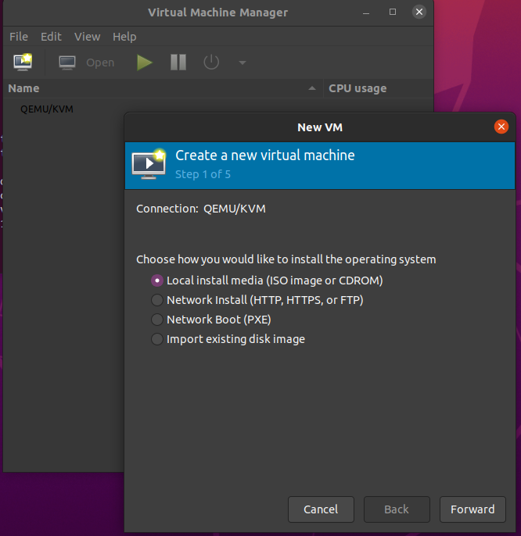
Fig: GUI Virtual Machines Dialog Box

